Q5. Read the following description of a relational data base before answering Sub-Questions 1 and 2.

This relational data base consists of a customer table, an order table, an order details table, and a product table.
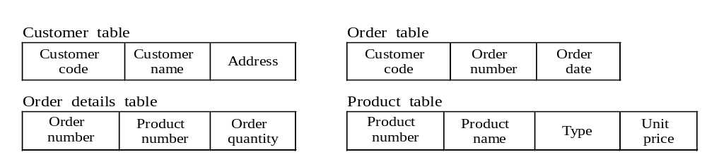

Sub-Question 1
After writing the SQL code shown in the following example in order to obtain the data listed below, several of your superiors found a problem in your code. What problem did they find? Select the correct answer from the choices provided below:
Order number | Customer name | Order amount
Example:
SELECT Order_Details_Table.Order_Number, Customer Name, SUM (Order Quantity * Unit Price)
FROM Order_Details_Table, Customer_Table, Product_Table, Order_Table
WHERE Customer_Table.Customer_Code = Order_Table.Customer_Code
AND Order_Details_Table.Product_Number = Product_Table.Product_Number
AND Order_Details_Table.Order Number = Order_Table.Order_Number
Answer group:
a) You can join no more than three tables in one SELECT statement.
b) You cannot use the SUM function to get totals when you join multiple tables.
c) You need to add “GROUP BY Order_Details_Table.Order_Number.”
d) You need to add “GROUP BY Order_Details_Table.Order_Number, Customer_Name.”
e) You need to add “ORDER BY Order_Details_Table.Order_Number.”

Sub-Question 2
You want to find out the type of product ordered by the customer with Customer code A156 ordered. Select the correct answers to be inserted into the corresponding boxes () in the following statements from the choices provided:
(1) Table 1 shows the results obtained by executing the following SQL code (which is designed to extract the product numbers):

SELECT Product Number FROM Order_Table, Order_Details_Table
WHERE Customer_Code = ‘A156’ AND Order_Table.Order_Number = Order_Details_Table.Order_Number
After executing SQL code ① (which further joined the product table) in order to retrieved the product types,  items were retrieved. After changing SQL code ① to SQL code ②, which uses a secondary sub-query, and then executing SQL code ②,  items were retrieved. Table 2 lists the product numbers and types.

SQL code ①
SELECT Type FROM Order Table, Order Details Table, Product Table
WHERE Customer Code = ‘A156’ AND Order Table.Order Number = Order Details Table.Order Number
AND Product Table.Product Number = Order Details Table.Product Number

SQL code ②
α

SELECT Type FROM Product Table WHERE Product Table.Product Number IN
(SELECT Order Details Table.Product Number FROM Order Details Table, Order Table
WHERE Customer Code = ‘A156’ AND Order Details Table.Order Number = Order Table.Order Number)

(2) When DISTINCT was inserted at the position indicated by α in SQL code (2),  items were retrieved.
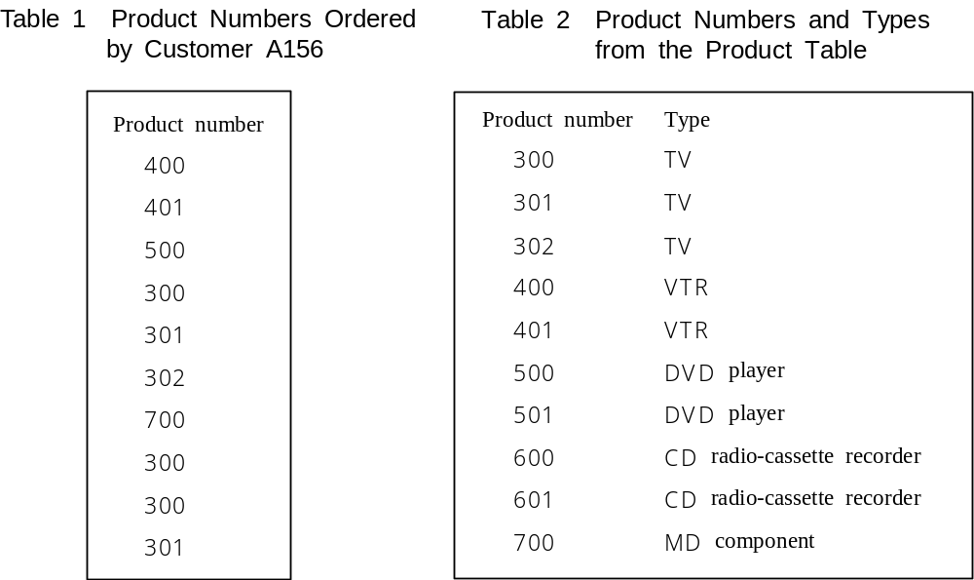

Answer group for a, b, and c:
a) 4 b) 5 c) 6 d) 7 e) 8 f) 9 g) 10

